PR 101 Project Report

Human Tracking Fan

By

Group No. - 21
Shubham Khandelwal (2017350)
Abhishek Vishwakarma (2017016)
Abhishek Meena (2017306)
Bhoor Singh Meena (2017078)
Ashok Kumar Meena (2017063)



Department of Mechanical Engineering
Indian Institute of Information Technology, Design And Manufacturing Jabalpur

25 JULY,2018

1. Introduction
- Unfortunately, today fans do not have very efficient or useful features when it is desirable to change the direction of air flow.

- Fans usually is static and needs to be physically redirected to direct air in the desired direction It requires physical effort which may be difficult if the user is of elderly age.

- The fan can rotate back and forth at a set angle which is approximately 180 degrees. This option is wasteful as the fan may direct air at empty spaces for much of the rotation cycle.

Thus, we decided to focus on a project that could solve the daily stresses and inconveniences of fan use by automating the process.

Need of Project

- Our project will be useful in offices, hostels, railway stations, hospitals.

2. Project Idea

Origin:

- We live in a society where fans are very prevalent whether it is an office, a hospital, a railway station or a bus stand.
- But fans usually provide air in the places where the person is not sitting which causes wastage of energy which is not good.
- It also requires multiple attempts to put the fan in the right position. It also causes in comfortability to elderly and differently abled people.
- So, we decided to pursue this project because we had fed up with these limitations of fan.

Sketch 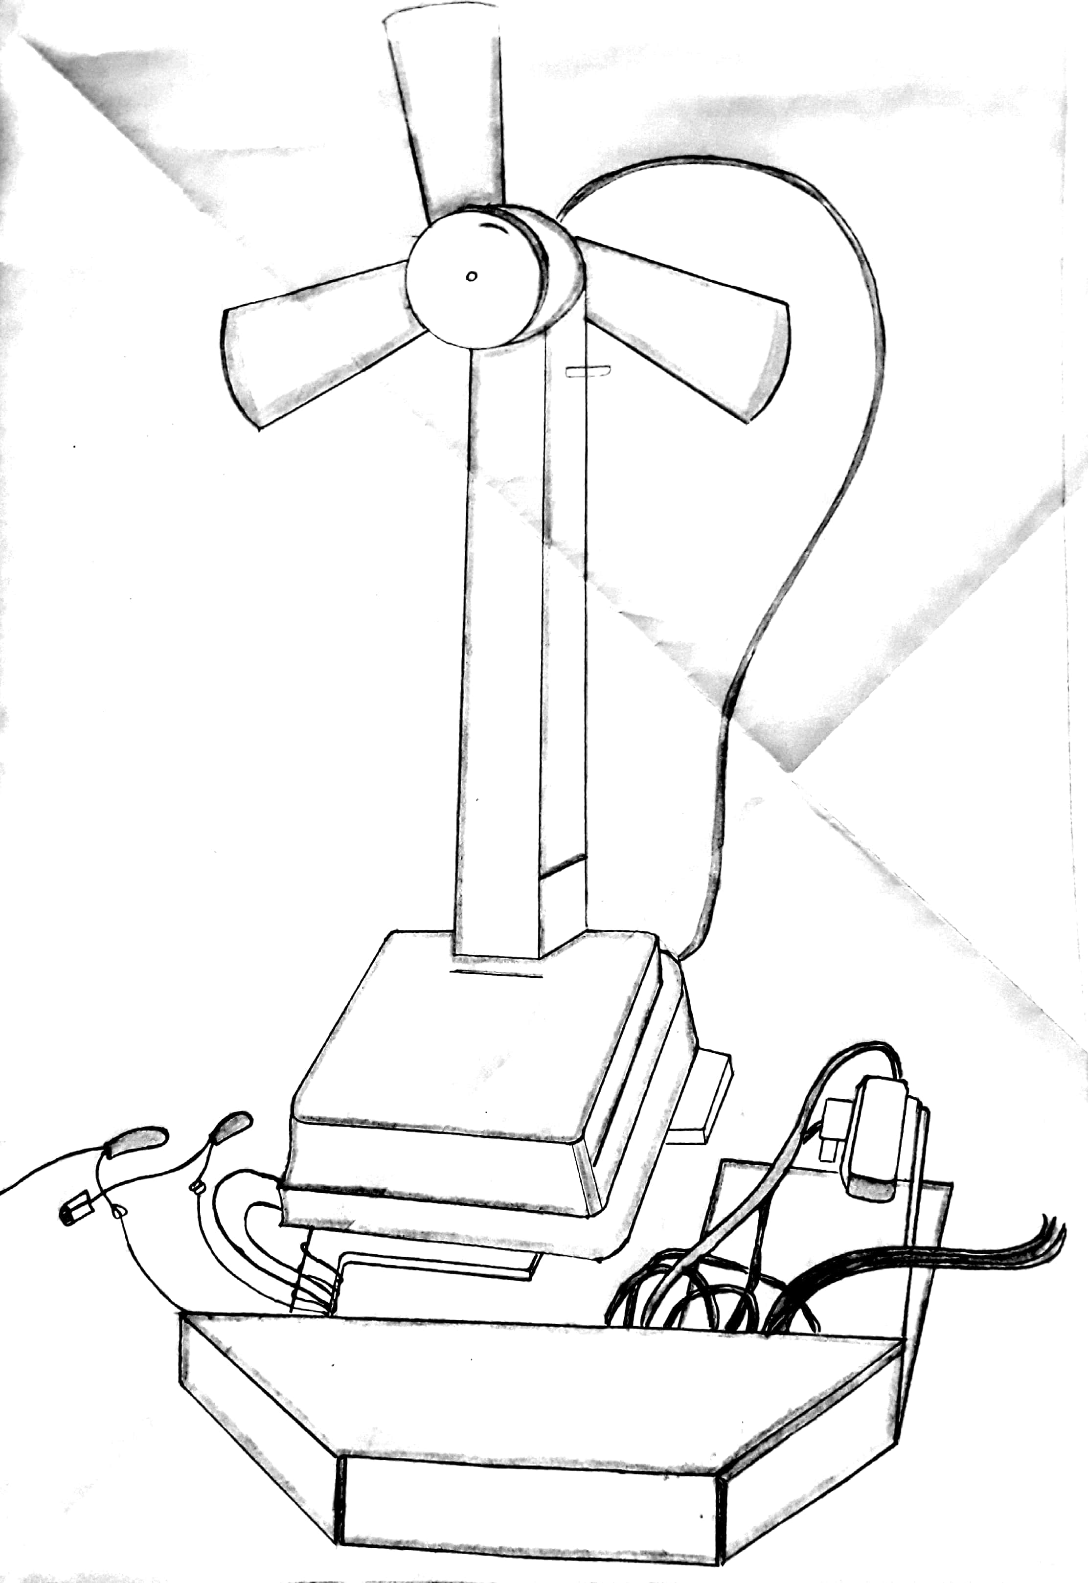
Fig 1.

Cad model
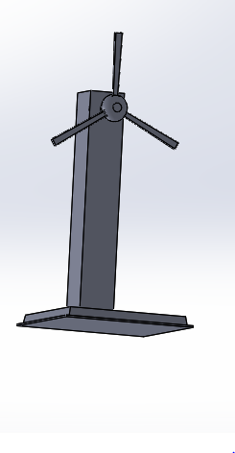
Fig 2.

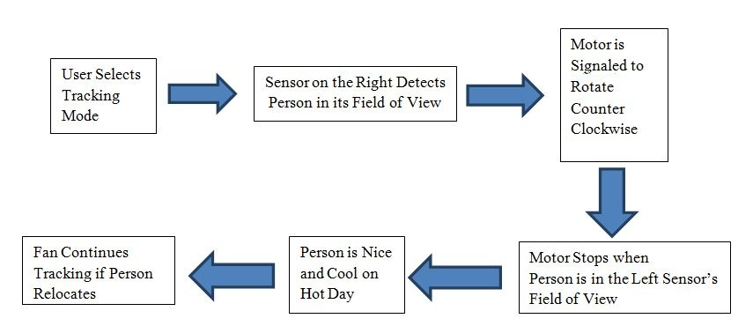
Fig 3. Flowchart

Explanation:
- When a person is in the field of view of sensor the output will be transferred to the Arduino board.
- Then Arduino will process the output and it will turn the attached servo motor to that position and will make the fan on.
- When another sensor detects the person the same process will be repeated.
- If there are two persons in the sensors field of view the fan will rotate in between the two persons.
- And if there is no person in the field of view of the sensor the fan will be stopped at an angle of 90 degrees.
Environment related benefits:
- Our project will be helpful in conserving energy by providing air to the places only where person is sitting and not in the empty spaces.
3.Applications
- We can use this fan in any public area like railway stations, airport, bus stand etc.

- It can also use in our hotel, office and homes.

- It will be a boon to elderly and differently abled people.



Fig 4.
Fig 5

4.Design and fabrication Details

Material Details:

1.Arduino:
Arduino is used for coding purpose and it is heart of our project. 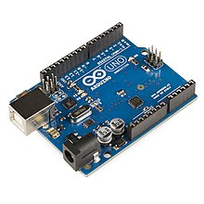 Fig 6.Arduino

2.Bread board:
Bread board is used for circuiting.
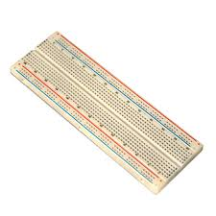Fig 7. Bread Board
3.Jumper Wires:
They are used for connections in our project.
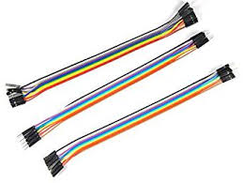Fig 8. Jumper wires
4.Servo Motor:
Servo Motor is used to turn the fan to the location where the person is sitting.
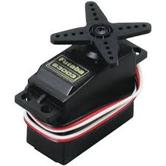Fig 9. Servo motor

5.DC Motor:
DC motor is used to turn the fan on and provide the cool air to the person sitting.

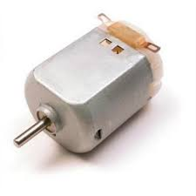Fig 10.DC motor

6.Proximity Sensor

This sensor will be used to detect the presence of man and will send the output to Arduino.

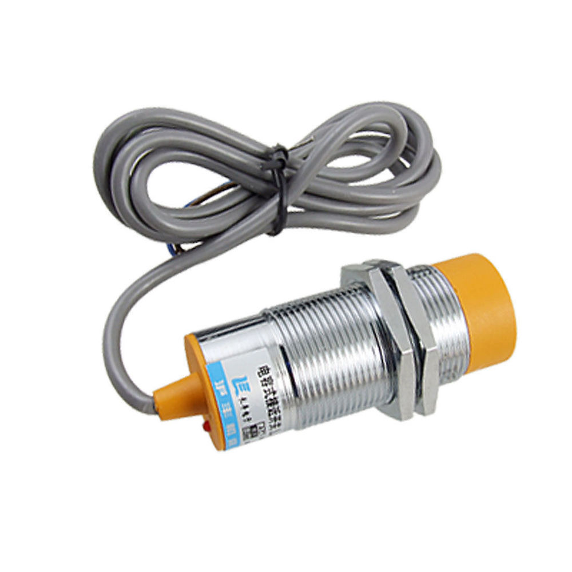
Fig.11 Proximity Sensor
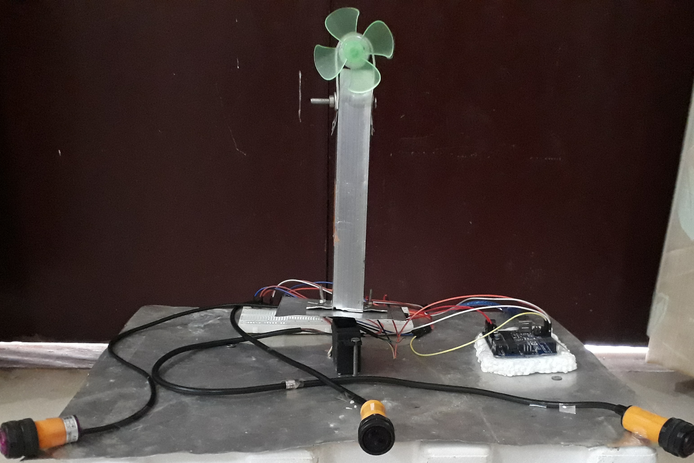

Fig 12. Fabricated Project

Coding Details

#include <Servo.h>
int ir=7;
int is=8;
int it=11;
Servo motor;
int a=0;

void setup() {
Serial.begin(9600);
motor.attach(9);
pinMode(ir,INPUT);
pinMode(is,INPUT);
pinMode(it,INPUT);

}
void loop()
{
if(digitalRead(ir)==LOW){
for(int a=0;a<60;a+=5){
motor.write(a);
delay(100);}

for(int a=60;a>=1;a-=5)
{
motor.write(a);
delay(100);
}
}

else if(digitalRead(is)==LOW){
for(int a=60;a<120;a+=5){
motor.write(a);
delay(100);}

for(int a=120;a>=60;a-=5)
{
motor.write(a);
delay(100);
}
}

else if(digitalRead(it)==LOW){
for(int a=120;a<180;a+=5){
motor.write(a);
delay(100);}

for(int a=180;a>=120;a-=5)
{
motor.write(a);
delay(100);
}
}
else
{
motor.write(90);
}

if(digitalRead(ir)==LOW&&digitalRead(is)==LOW)
{
for(int a=0;a<120;a+=5){
motor.write(a);
delay(100);}

for(int a=120;a>=1;a-=5){
motor.write(a);
delay(100);}
}

if(digitalRead(is)==LOW&&digitalRead(it)==LOW)
{
for(int a=60;a<180;a+=5){
motor.write(a);
delay(100);}

for(int a=180;a>=60;a-=5){
motor.write(a);
delay(100);}
}

if(digitalRead(ir)==LOW&&digitalRead(it)==LOW)
{
for(int a=0;a<180;a+=5){
motor.write(a);
delay(100);}

for(int a=180;a>=1;a-=5){
motor.write(a);
delay(100);}
}

}

5.Future Scope

- In near future our project will be of great help to the people working in hospital, offices, railway stations and many public areas as they do not need to change the position of fan as they used to do it in the earlier times.

- Our project will revolutionise the concept of making fan. This concept will be of great support to the elderly and differently abled people.

- This idea could also be extended lights, Air Conditioners, Television and many other technical appliances of daily use.

- Our project could also be used as a Burglar Alarm.

References

1.Instructables.com(https://www.instructables.com/id/Proximity-Sensor-for-Arduino-MCU-Using-555-Timer-I/)

2.You Tube (https://www.youtube.com/watch?v=ZySGP4AwGCY&t=476s)

3.Circuitmagic.com

4.Toptechboy.com (www.toptechboy.com/arduino/lesson-16-controlling-a-servo-with-arduino)

5.Journal: Cornell University
(https://people.ece.cornell.edu/land/courses/ece4760/FinalProjects/s2011/esp57_jmf293/esp57_jmf293/index.html.html)

